1. Report the account representative for each customer

**Query:**

select a.customerNumber,a.customerName,a.salesRepEmployeeNumber,concat(b.firstName,' ',b.lastName) as salesRepEmployeeName from customers as a left join employees as b on a.salesRepEmployeeNumber=b.employeenumber;

**Screenshot:**

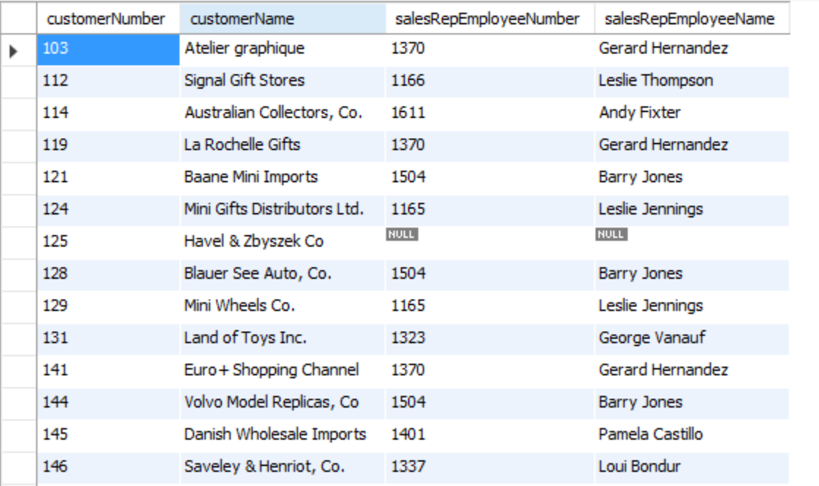

1. Report total payments for Atelier graphique

**Query:**

select a.customerName,sum(b.amount) as Total_Sum from customers as a left join payments as b on a.customerNumber=b.customernumber where customerName='Atelier graphique';

**Screenshot:**

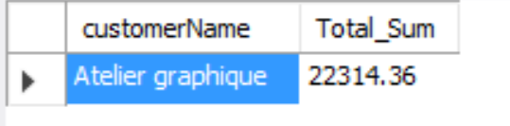

1. Report the products that have not been sold

**Query:**

select * from products where productcode not in (select distinct(productcode) from orderdetails);

**Screenshot:**



1. List the amount paid by each customer

**Query:**

select a.customerNumber,a.customerName,sum(b.amount) as Total_Payment from customers as a left join payments as b on a.customerNumber=b.customernumber group by a.customerNumber ;

**Screenshot:**

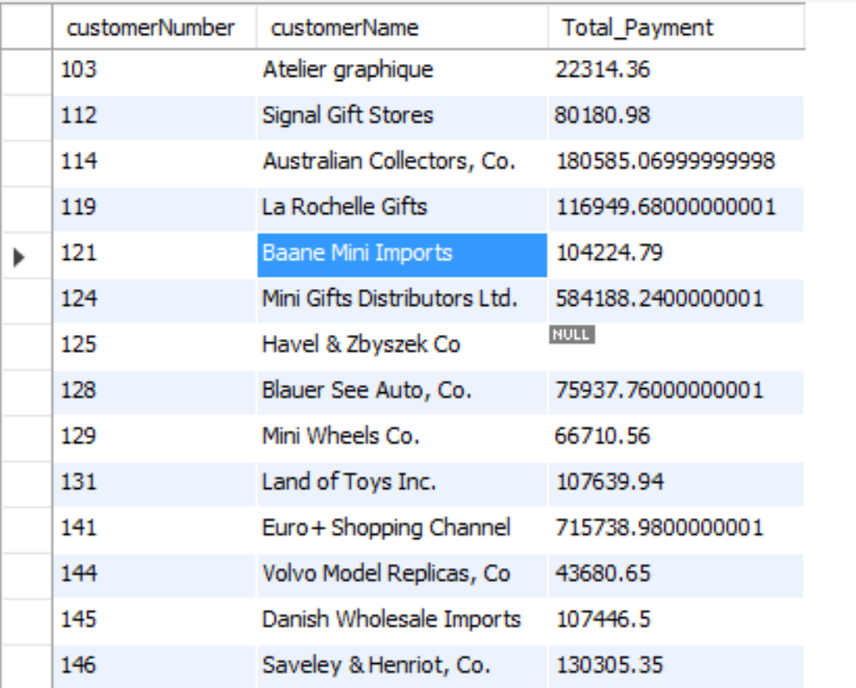

1. List names of products sold by order date

**Query:**

select c.productCode,c.productname,d.ordernumber,d.orderdate from products as c join (select a.orderNumber,a.orderdate,b.productcode from orders as a left join orderdetails as b on a.orderNumber=b.orderNumber ORDER by a.orderdate asc) as d on c.productcode=d.productcode;

**Screenshot:**

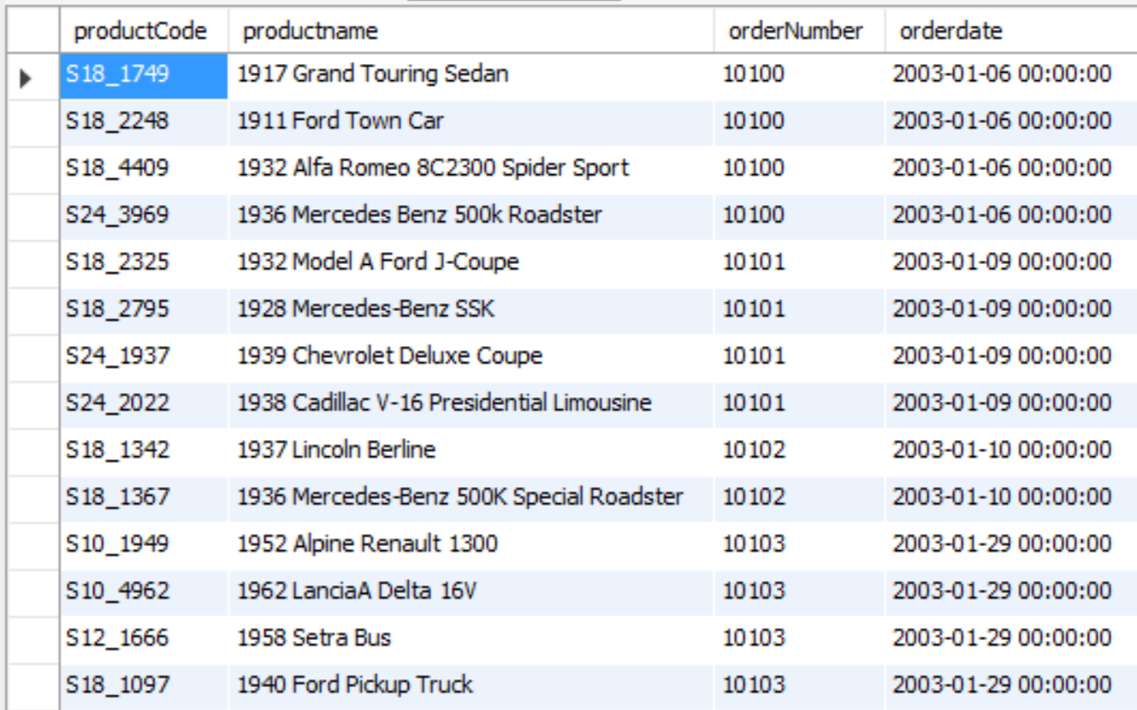

1. List all the order dates in descending order for orders for the 1940 Ford Pickup Truck

**Query:**

select b.productcode,b.productname,a.orderDate,b.orderNumber from orders as a right join (select c.orderNumber,c.productcode,d.productname From orderdetails as c join products as d on c.productCode=d.productcode where d.productname= '1940 Ford Pickup Truck') as b on a.ordernumber=b.ordernumber order by a.orderdate desc;

**Screenshot:**

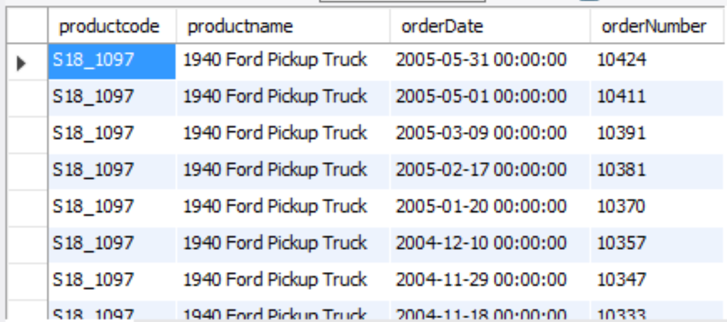

1. Report the number of customers in Denmark,Norway, and Sweden

**Query:**

select country,count(*) from customers where country in ('Denmark','Norway','Sweden') group by country;

**Screenshot:**

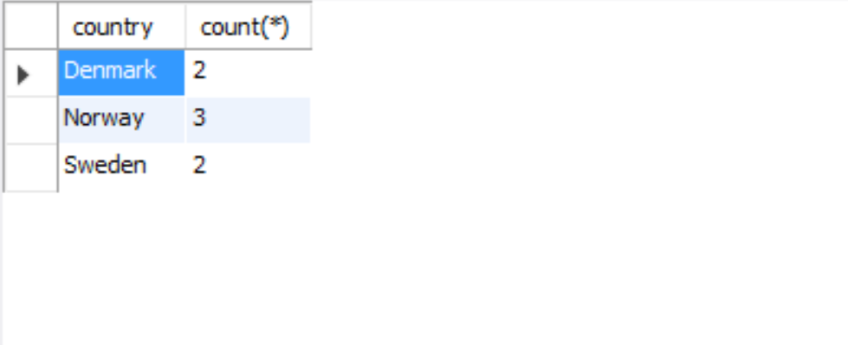

1. List the products with a product code beginning with S700.

**Query:**

select productName, productCode from products where productCode regexp ('^S700');

**Screenshot:**

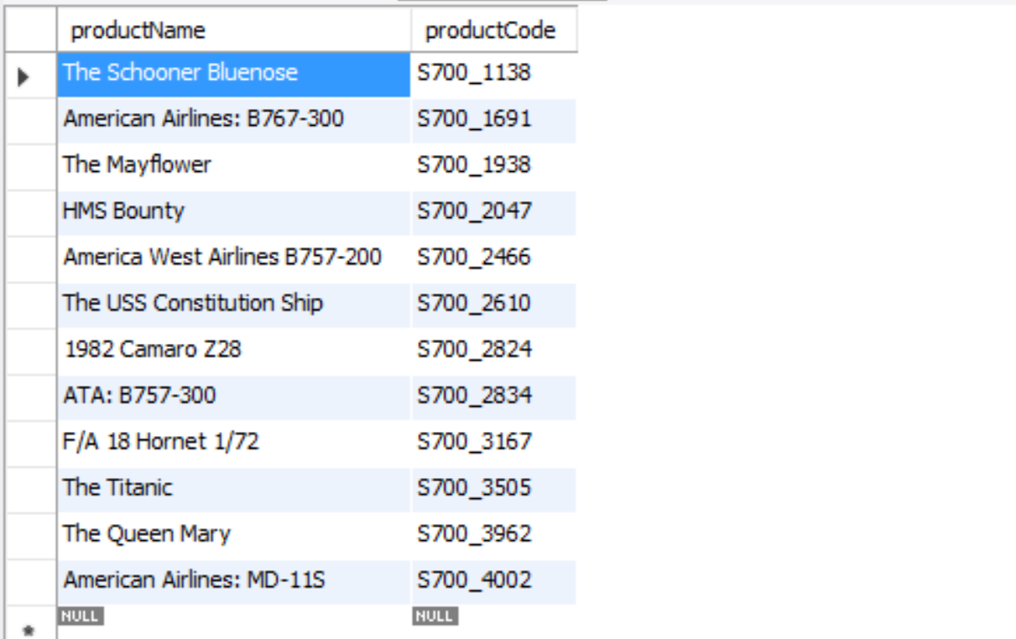

1. Who is at the top of the organization (i.e.,reports to no one).

**Query:**

select Concat(firstname,' ',Lastname) as full_name,firstName,lastname,employeenumber,reportsTo from employees where reportsTo is null;

**Screenshot:**

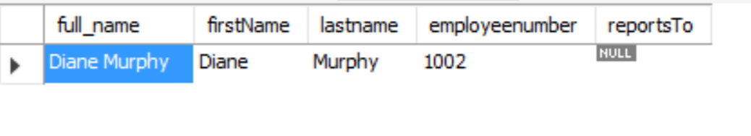

1. Who reports to William Patterson?

**Query:**

select Concat(firstname,' ',Lastname) as full_name,firstName,lastname,employeenumber,reportsTo from employees where reportsTo in ( select employeenumber from employees where firstname='William ' and lastname='Patterson' );

**Screenshot:**

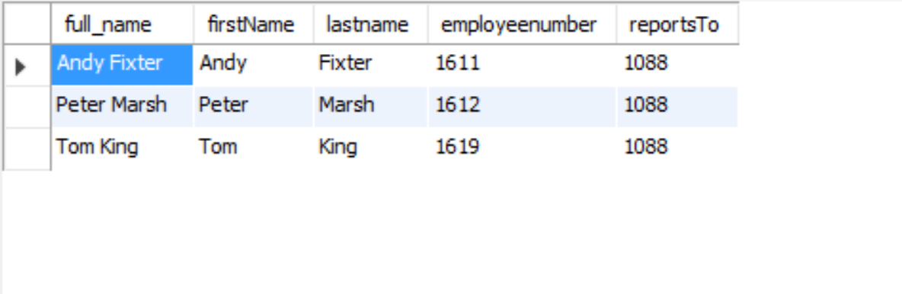

1. List all the products purchased by Herkku Gifts

**Query:**

select e.productcode,e.productname,f.ordernumber,f.customerName,f.customerNumber from products as e join (select c.ordernumber,c.productCode,d.customerName,d.customerNumber from orderdetails as c join (select a.customerNumber,a.customerName,b.ordernumber from customers as a join orders as b on a.customerNumber=b.customerNumber where a.customerName='Herkku Gifts') as d on c.orderNumber=d.orderNumber) as f on e.productcode=f.productcode;

**Screenshot:**

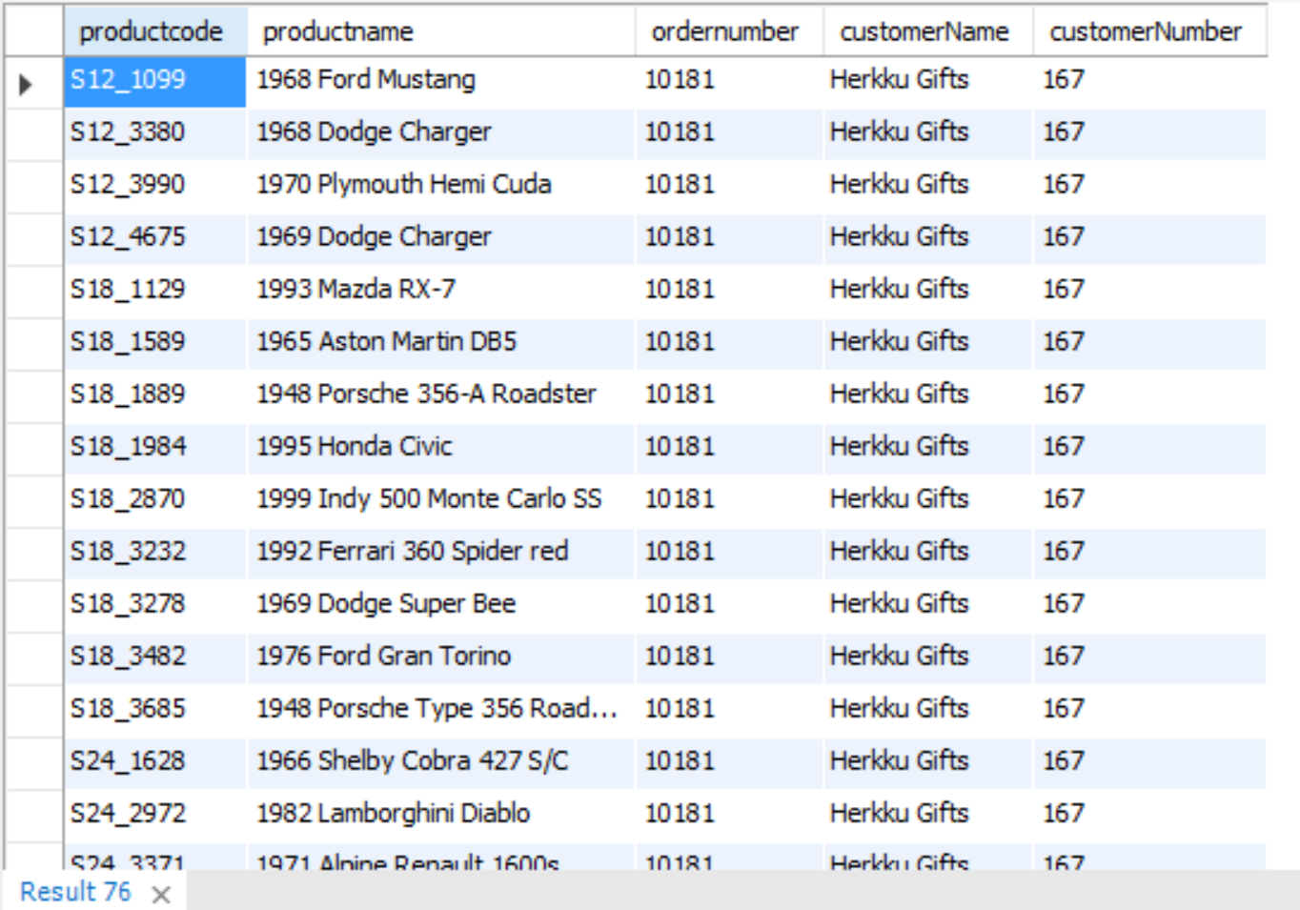

1. Compute the total value ordered, total amount paid, and their difference for each customer for orders placed in 2004 and payments received in 2004. Only report those customers where the absolute value of the difference is greater than $100. (Hint: Create views for the total paid and total ordered).

**Query:**

1. create view total_order_value as select a.customerNumber,sum(b.quantityOrdered*b.priceEach) as total_order_Value from orders as a join orderdetails as b on a.orderNumber=b.ordernumber where a.orderdate between '2004-01-01 00:00:00' and '2004-12-31 23:59:59' group by a.customerNumber;
2. create view total_payment as select customerNumber,sum(amount) as total_payment from payments where paymentDate between '2004-01-01 00:00:00' and '2004-12-31 23:59:59' group by customerNumber;
3. select *,abs(c.total_order_Value-d.total_payment) as difference from

(select a.customernumber,a.customerName,b.total_order_Value from customers as a left join total_order_value as b on a.customerNumber=b.customerNumber) as c

join

(select a.customernumber,b.total_payment from customers as a left join total_payment as b on a.customerNumber=b.customerNumber) as d on c.customerNumber=d.customerNumber where abs(c.total_order_Value-d.total_payment)>100;

Screenshot:

